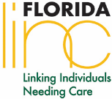
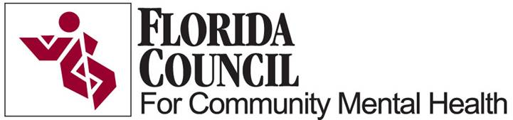

Florida’s Growing Public Health Problem: Suicide

Compared to the national average, Florida’s suicide rate is higher (13.8 vs. 12.93 per 100,000; CDC, 2014), making it one of the leading causes of death among all Floridians. Over the last ten years, the overall number of suicides in the state has been on the rise, an increase of 24% (FL DOH, 2016).

Increased suicide rates have significantly impacted the following groups (FL DOH, 2016):
- Minorities: Suicides increased by 33% among African Americans and 65% among Hispanics
- Military populations
- Specific age groups:
  - Suicide is the 3rd leading cause of death among youth (ages 10-24)
  - 2nd leading cause of death among young adults (ages 25-34)
  - 4th and 5th leading cause of death among middle-age adults (ages 35-44 and ages 45-54, respectively)

Youth, in particular, continue to be at-risk. In 2013, Florida’s children and youth represented (see below table and map of suicide deaths per county):
- 4,752 Emergency Department visits for suicide attempts
- 1,909 hospitalizations for suicide attempts
- 246 suicide deaths (280 deaths in 2014)
- One child/youth dies by suicide every 32 hours

Suicide also has significant human capital and economic costs for the state.
- Number of deaths lost to suicide reflect a total of 49,282 years of potential life lost before age 65
- Economic cost of suicide reflects over 2.84 billion in combined lifetime medical and work losses (AFSP, 2016)

How can Florida address this issue?
One way to make inroads in the prevention of suicidal behaviors (suicide ideation, suicide attempts and deaths) is to improve state level data surveillance.

Florida partners must work together to determine the best ways to gather information that is usable and actionable towards the common goal of finding out who is suffering and dying in Florida.

Why is this important?
  - We must find out 1) the extent of the problem and 2) the impact of interventions in order to target resources effectively and efficiently
  - Preventative and intervention services/programs can be greatly informed by data and surveillance. The collection, monitoring, and sharing of such data increases the ability to:
    - Understand the problem, locate “hot spots”
    - Assess the impact of existing services
    - Identify gaps/barriers in existing systems/areas (geographical locations)
    - Identify systems, populations, and locations to target (current and future) efforts
    - Effectively target local, state, and federal funding to invest in services/programs that have an impact

How can the Children’s Cabinet help?
- Advocate for the creation of a state-level advisory/task group that can begin to investigate ways that state-level systems/local agencies are collecting, monitoring, and sharing data on suicide attempts and deaths
  - Create a data surveillance task force of state leaders, researchers, and other suicide prevention advocates with these specific objectives and goals:
    - Identify existing systems/agencies/entities collecting data and how they are using the data (goal: create an integrated system where all data is pooled)
    - Explore data sharing agreements between systems/agencies/entities (goal: create agreements between systems)
    - Examine existing metrics used to define suicidal behaviors (goal: create a universal process)
    - Explore other gaps/barriers that hinder data collection processes
- Identify state-level partners that could apply for future federal funding to enhance the state’s existing data surveillance system (relating to behavioral health indicators, especially the collection of suicide attempts and deaths)
- Advocate for an improved data surveillance system which pools multiple sources together so that local and state-level systems can use reliable information to guide prevention and intervention efforts (this is a primary goal for SAMHSA)

For further information contact Mike Hansen at the Florida Council for Community Mental Health at mike@fccmh.org or Kim Gryglewicz, PhD at kgryglew@ucf.edu

