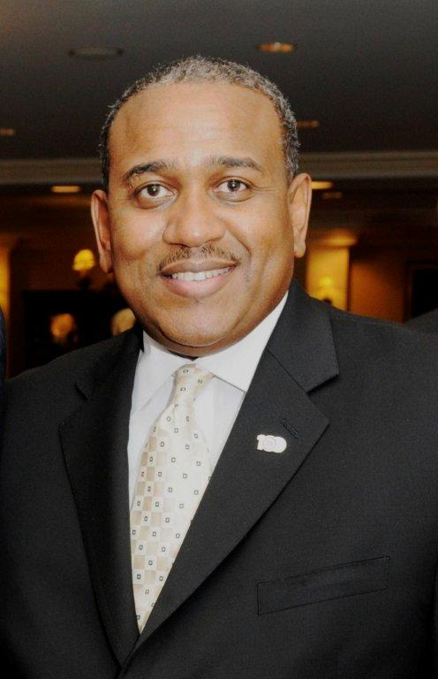
Allie L. Braswell, Jr.
President and CEO
Central Florida Urban League

Allie Braswell is the President and CEO of the Central Florida Urban League (CFUL). He has led the CFUL since February 2010. As President and CEO of the Central Florida Urban League, Allie is responsible for leading the efforts to maintain and grow the extensive network of educational, cultural and community partners and alliances that embrace and articulate the organization’s goals. He is responsible for the overall management of the agency as well as overseeing the implementation of policies and procedures issued by the CFUL’s Board of Directors and the National Urban League of which CFUL is an affiliate.
Allie Braswell is also a proud military veteran, having served 13 years in the United States Marine Corps. He continues his service to the country, and our region as a US Army Reserve Ambassador, and most recently was appointed to the Advisory Committee for the Center for Minority Veterans by the Honorable Eric K. Shinseki, Secretary of Veteran Affairs. His support and endorsement of many civic and charitable endeavors has earned him additional recognition from community leaders and organizations nationwide.

