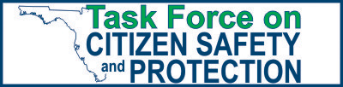
Listening to the people

Over 10,000 citizen inputs!
9,180 Emails
100 Postal
550 Calls
60 Comment cards
140 Public speakers

Engaging the experts

Police Detectives
Sheriffs
Public Defenders
Prosecutors
Professors
Crime Prevention Coordinator
Victim Service Advocate
Neighborhood Watch Volunteer
Community Associations
Security Companies
Civil Rights Organizations
2nd Amendment Rights Groups

Gathering the facts

10 Hours of expert testimony and Q&A
10 Hours of Member deliberation
30+ Documents received at meetings

Providing open, transparent, and assessable information

The Task Force website is the information center for all the Task Force’s work.
Every Task Force meeting is carried live and streamed live on the FL Channel website.
Every Task Force meeting is videoed archived on the Task Force website.
Every citizen communication is available on the Task Force website.
Every document provided the Task Force is available on the website.
www.FLGOV.COM/CitizenSafety

