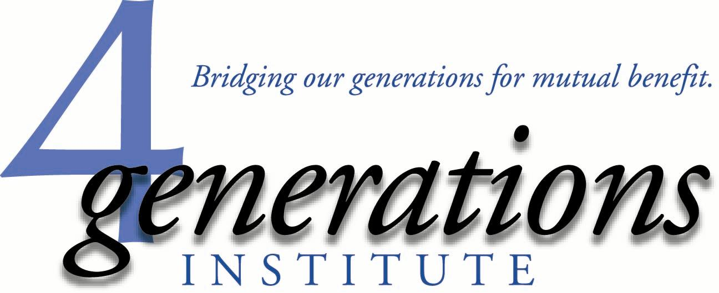

Florida Youth Commission

Leadership Development for Florida’s Future

Building upon the strengths of Florida’s diverse youth leadership programs which currently serve a proportion of the more than
1-million Florida young people ages 15-19, the Florida Youth Commission has the potential to become a vehicle for not only individual achievement, but stands to serve as a vehicle for collective impact.

The Florida Youth Commission, a creation of the Florida Children and Youth Cabinet, would be organized to attract members whose individual life experiences and personal community service is magnified through learning the strategies and skills of advocacy and civic engagement.

The seeds of a lifetime of community leadership, in the right learning and mentoring environments, can grow to their fullest potential.

The Florida Youth Commission would serve in an advisory role the Florida Children and Youth Cabinet reflecting the voices of our state’s emerging leaders in matters of public policy, program initiatives, community service, creative philanthropy and career development.

In order to most effectively focus on the roles, responsibilities and potential impact of the Youth Commission, a diversity of existing Florida youth development models would be studied to determine how their program structure and operations are relevant to the mission of the Youth Commission.
Among the existing Florida youth leadership programs to be engaged:

YMCA Youth in Government

Girls and Boys State (American Legion)

Boy Scouts and Girl Scouts

Kiwanis Key Club, Builders Club and Circle-K

Rotary Youth Leadership Academy

Community-based Youth Leadership (Chamber of Commerce/Philanthropy)

4-H and Future Farmers of America

ABLE Trust Florida Youth Leadership Institute

Florida Sheriffs Explorers

Boys and Girls Clubs

Big Brothers/Big Sisters

Take Stock in Children

Bright Futures Scholarship/Community Service

Children’s Services Councils

United Ways

In addition, a wide range of interest-specific organizations include:

- Sororities and Fraternities, Faith-based Youth Groups, and school and community-based Sports and Recreation, Band and Theatre, Science and Technology, Environmental, and Creative Arts clubs, teams and organizations.

- There is a diversity of community-based and residential programs which serve young Floridians who are involved in our various systems of care, including child welfare/foster care, youth justice, education, substance abuse/mental health and services for special needs/developmentally challenged youth.
Each of these programs has the potential to play a valuable role in identifying voices of youth whose experiences should be leveraged to magnify the impact of the Commission’s work in civic engagement and advocacy.
Recommended Next Steps/Program Outreach Tasks:

To launch this re-invigoration of the Youth Commission the following five activities should be undertaken, setting the stage for future growth and development:

- A compendium of current youth development programs operating in Florida would be assembled to examine their diversity of membership, methodology of recruitment, service design and educational offerings.

- Once this list is developed, a mapping of their locations, meetings schedule and special events (e.g. conferences and trainings) would provide the opportunity to share educational offerings which focus on civic engagement and advocacy.

- A curriculum would be created which provides youth development organizations an educational basis upon which to build their strategic plan for incorporating civic engagement into their program offerings.

- Mentors would be recruited and trained to provide both inspirational and educational services to interested youth development entities at existing and newly-created venues.

- An evaluative instrument would be developed and implemented to measure the success of the youth leadership educational offerings.

Recommendation for an Organizational Home:

The Ounce of Prevention Fund of Florida, now it its 27th year of operation, is a public/private partnership which provides a diverse program development and implementation role in cooperation with a range of governmental, philanthropic and policy entities at the national, state and community levels.

Given the opportunity, the Ounce of Prevention Fund would be interested in negotiating a service relationship which would include the research, organizational tasks and developmental steps necessary to implement the Florida Youth Commission for the 2016-2017 program year.

Submitted for review and discussion by:

Jack Levine, Founder
4Generations Institute
jack@4Gen.org
850.567.5252

