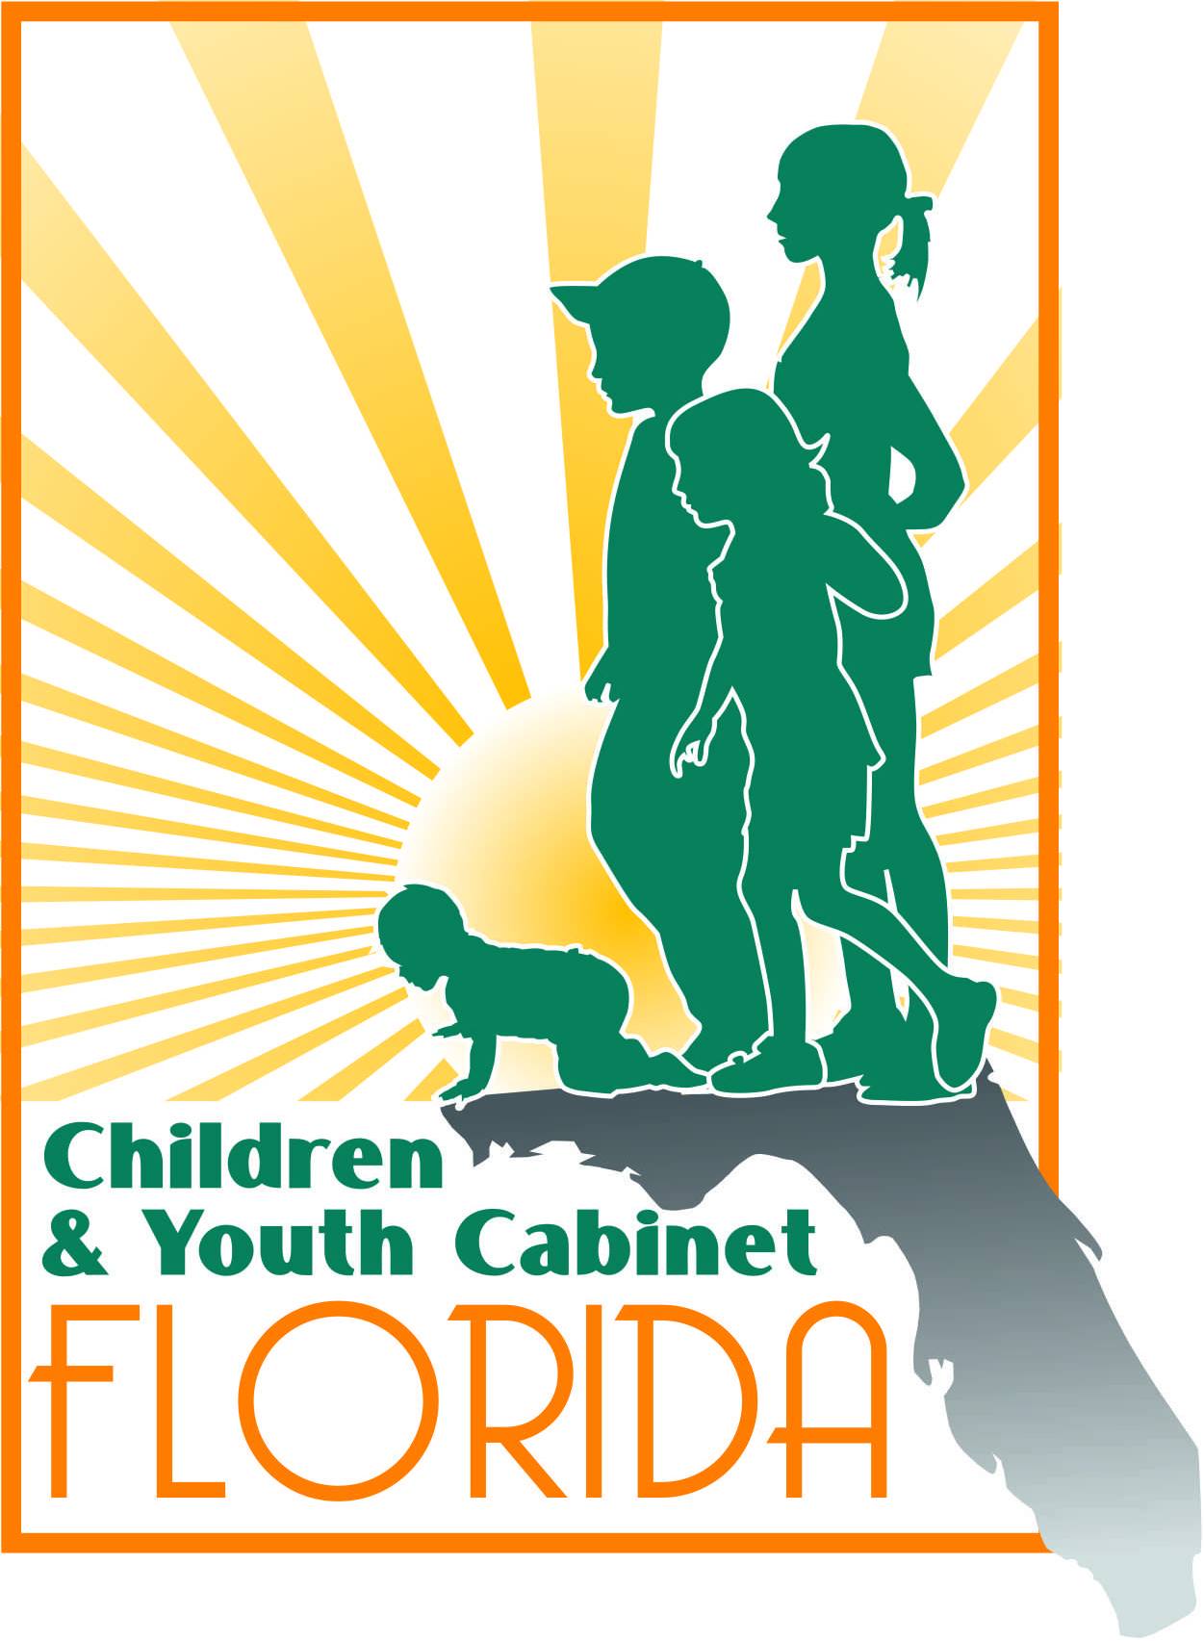
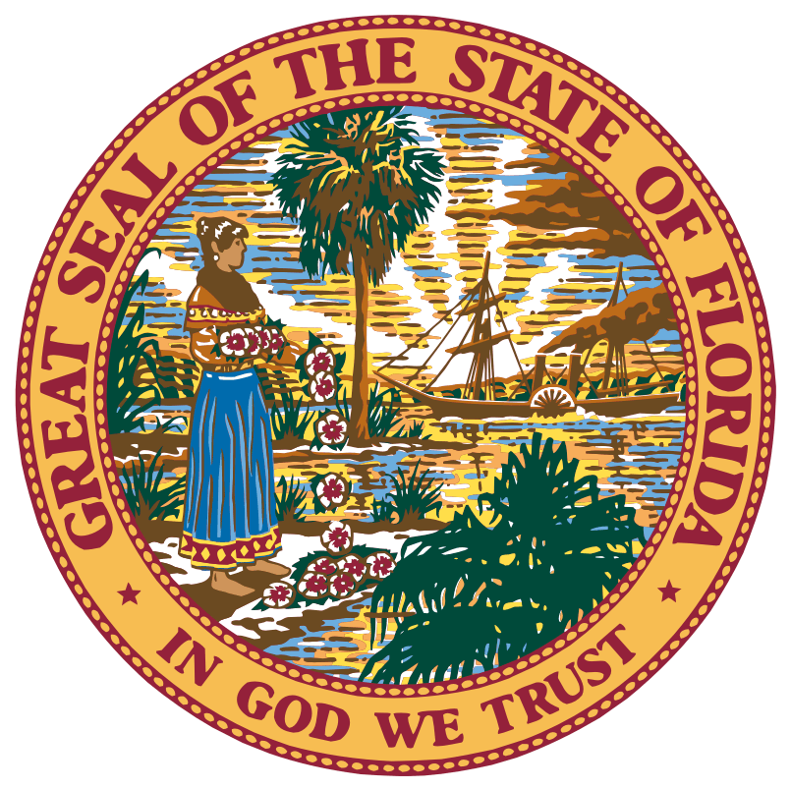
Florida Children and Youth Cabinet Meeting
Monday, March 25, 2019
1:00 p.m. – 4:00 p.m. EST
Cabinet Meeting Room, The Capitol Lower Level
400 S. Monroe Street
Tallahassee, FL 32301

Meeting Summary

Note: The following is a summary of the highlights of the proceedings and is not intended to be construed as a transcript. To obtain meeting materials, please visit www.flgov.com/childrens-cabinet.

- Call to Order and Welcome
  - Chair, Wansley Walters, gave a warm welcome to the Cabinet and called the meeting to order at 1:00 p.m.
  - The roll was called by Ms. Pat Smith and a quorum was confirmed.

    - FCYC Members in Attendance:
      - Chair Wansley Walters
      - Director Alan Abramowitz
      - Secretary Chad Poppell
      - Secretary Simone Marstiller
      - Director Zack Gibson
      - Judge Sandy Karlan (via phone)
      - Director Rodney MacKinnon
      - Director Barbara Palmer
      - Diana Ragbeer
      - Victoria Zepp
      - Tanya Wilkins
      - Steve Uhlfelder
      - Superintendent Sandra Himmel

    - Members Absent:
      - Berthy De La Rosa-Aponte
      - Secretary Mary Mayhew
      - Surgeon General, Scott Rivkees, Dept. of Health
      - Commissioner Richard Corcoran, Dept. of Education – (Chancellor, Jacob Oliva represented on his behalf)

    - Staff in Attendance:
- Pat Smith
- Jennifer Hirst

Proceedings
Chair Walters took the opportunity to recognize Pat Smith and the Florida Department of Children and Families for the work done with the Florida Children and Youth Cabinet’s preparation.
Chair Walters acknowledged Florida’s Children’s Week at the Capitol. Cabinet members were encouraged to participate in various activities as well as attend the annual Children’s Week Award Dinner and Reception following the meeting.
Before discussing the agenda, Chair Walters graciously welcomed new members and allowed everyone to provide brief introductions.
- Agency Legislative Agenda Updates
  - Secretary Chad Poppell, Department of Children and Families: Highlighted two legislative items including the Title IV-E waiver changes and funding. There will be some policy and procedural changes at DCF. Additionally, he addressed the matter of having public records exemption for foster parent names, to protect their identities for public safety reasons.
  - Secretary Simone Marstiller, Department of Juvenile Justice: No policy legislation this session. The Department is concentrating on legislative budget priorities to include expanding and continuing prevention and diversion programs and increasing the ability to ensure quality oversight of residential providers. DJJ will continue focusing its efforts on increasing public safety by creating more program monitoring.
  - Barbara Palmer, Agency for Persons with Disabilities: No policy legislation this session. The agency is facing big challenges in the budget process. Due to the sheer number of individuals on the Florida Waitlist, $40 million has been proposed to assist with transitioning individuals off the Waitlist onto the Waiver Program to begin receiving services. There has also been a call for additional legislative funding for the certified board to cover a deficit due to increased service needs among families. APD serves people from birth to death. The agency was pleased to transition 160 clients out of Carlton Palms Educational Center, a residential facility for severely disabled persons where unfortunately, abuse and neglect took place. The agency was successful in transitioning those clients within four months, moving them into the community and closer to family members.
  - Director Rodney MacKinnon, Office of Early Learning: No policy legislation this session. The OEL has a budget request to provide authority to spend a significant award of federal funds that the OEL received regarding the School Readiness Program which serves about 200,000 children of low-income working families. They have a wait list of about 25,000. The increase of funding will help reduce the agencies waiting list for services.
  - Director Alan Abramowitz, Florida Guardian ad Litem Program: Mentioned two budget and legislative issues. Four years ago, there was a push for professionalization of investigations and case work. A new measure through the Certification Board will now provide certifications of social workers to support volunteers in the GAL program. This will improve advocacy. Furthermore, volunteer travel reimbursement is now available for volunteers traveling long distances or on a fixed income. GAL will be involved on the front with crossover kids who are in both the DCF and DJJ systems. He also spoke briefly about the Regis Little Act to protect children with special needs, which ensures vulnerable foster youth have a guardian in place at age 18.
  - Chancellor Jacob Oliva, Department of Education: Praise was given to Governor DeSantis and the State of Florida for proposing the increase in funding to improve security within schools, provide scholarships, and expand onsite job training for teachers and staff.
  - Superintendent Sam Himmel, Citrus County Schools: The topic of using threat assessments on students was discussed and appropriate next steps for engaging parents in children’s needs, if identified. The need for more mental health practitioners and social workers in schools was also mentioned to the Cabinet.
  - Director, Zack Gibson, Governor’s Office of Adoption and Child Protection: Provided an update on the Interagency Agreement which was signed by Cabinet members and multiple state and governmental entities. Through those efforts we can hopefully find other options to consider as we determine future threats.

- Policy Impact Committee Update
  - Diana Ragbeer provided a summary of the Kids Count data findings as having three main priorities including: mental health/substance abuse, children living in poverty, and early childhood development for children 0-3. The Committee would like to have another future retreat. Currently, the data-driven Cabinet priorities for 2020 includes the following nine actions of concern:
- Percentage of low birthweight babies born in Florida;
- Percentage of eligible children, under four years of age, not in school readiness or Early Head Start.
- Percentage of children, under four years of age, living at or below 200% of the federal poverty level.
- Percentage of infants and toddlers without health insurance.
- Children who are under 12 at first arrest.
- Percentage of victims of verified maltreatment who were not subjects of subsequent reports with verified maltreatment within 6 months (related to children removed from homes and returned or who remain in foster care).
- Percentage of children that are reading on grade level by fourth grade.
- Percentage of children with developmental disabilities placed in out of home placements.
- Reduction in the number of preventable child deaths that occur with a focus on ages zero to three.
There is also work being done to revive the previous 2010 Cabinet budget ensuring it is child focused at its core. The group plans to focus on soliciting community input, especially advocacy groups.
Judge Sandy Karlan will provide Chair Walters and Cabinet members with a copy of the previous proposed budget. Norin Dollard, Ph. D. Research Assistant Professor with the University of South Florida has been a huge asset to the Cabinet and was recognized for her leadership for all the great work being done in collaboration with the Policy Impact Committee on behalf of the Cabinet.

- Florida’s Action for Dental Health: Florida Dental Association Presentation
  - FDA President, Dr. Jolene Paramore, shared the importance of dental health and how tooth decay currently affects 55% of children and is the leading childhood disease. Poor dental health can also affect school performance and graduation rates. Due to these concerns, February is Children’s Dental Health Month and the agency hosts “Give Kids a Smile” events which offer free dental care to children. Furthermore, the agency is looking to apply more preventative measures starting from the Well Baby Checkup to detect children at high risk for tooth decay as early as age one. Director of APD, Barbara Palmer, echoed the importance of dental care as well as the difficulties associated with performing dental care on those with developmental disabilities.

- Whole Child Leon & Tallahassee Behavioral Health Center Presentation
  - Executive Director, Courtney Atkins, discussed the role of Whole Child Leon as a catalyst for providers and parents to solve issues affecting children in our community. The importance of prenatal as well as age 0-5 care was discussed and Whole Child Leon’s role in linking parents with those needed services. Whole Child Leon is also working to address the childhood obesity epidemic by teaming with Leon County Schools as well as city garden initiatives to incorporate healthy cooking and eating habits. Alexis Rojas, Executive Director of the Tallahassee Pediatric Behavioral Health Center, discussed the program and its focus on mental and behavioral health services for children. Currently, the agency receives grant funding to conduct biopsychosocial evaluations and psychoeducation from referrals received by local pediatricians or the Early Learning Coalition.

- Public Comments
  - Dr. Blackman discussed the point of truly thinking what the Cabinet’s role must play into supporting families who do not live in ideal environments, as well as how that environment impacts children in the womb.
  - Executive Order 1932, with the Department of Education’s Florida standards review, is open for comments/input from relevant stakeholders. The information is available at the following website: fldoe.org/standardsreview

- Closing
  - Members agreed without objection. Location, time and venue for the next meeting will be announced at a later date.

- Adjournment
  - The meeting adjourned at 2:30 p.m.

